# **Testing**

## Unit Tests

I unit tested all the methods in all of the services in the domain layer. I used the Moq library to pass in a mocked version of the entity framework database to allow me to setup the database how I need it for each test case. This was also useful the be able to call back what was sent into the mocked database to check if data was being transferred correctly and to make it throw exceptions to check how the methods react. I used the Nunit testing framework for this. I also used fluent assertions to make my code more readable and make the assertions easier to write.

### Session Service Unit Tests

|  |  |  |  |  |  |
| --- | --- | --- | --- | --- | --- |
| Test Number | Test description | Test Tools | Expected Outcome | Result of Test | Pass/Fail |
| 1 | This is a test for the method which handles logging in. When a card which has an invalid card id is entered the method throws an Invalid Card Type Exception. | Nunit, Moq | Throws Invalid Card Type Exception | Throws Invalid Card Type Exception | Pass |
| 2 | This is a test for the method which handles logging in. A valid user entry is inputted and no exception should be thrown. | Nunit, Moq | Passes | Passes | Pass |
| 3 | This is a test for the method which handles logging in. A card which doesn’t exist is inputted and a  CardNotExistException should be thrown. | Nunit, Moq | Throws a Card Not Exist Exception | Threw a Card Not Exist Exception | Pass |
| 4 | This is a test for the method which handles logging in. An unregistered card is inputted and a  CardNotRegisteredException should be thrown. | Nunit, Moq | Throws a Card Not Registered Exception | Threw a Card Not Registered Exception | Pass |
| 5 | This is a test for the method which handles logging in. An invalid pin inputted into the method and a Invalid PinTypeException should be thrown. | Nunit, Moq | Throws a Invalid Pin Type Exception | Threw a Invalid Pin Type Exception | Pass |
| 6 | This is a test for the method which handles logging in. A incorrect pin is entered and a InvalidCredentialException should be thrown. | Nunit, Moq | Throws Invalid Credential Exception | Threw a Invalid Credential Exception | Pass |
| 7 | This is a test for the method which handles logging in. The credentials for a user which is already logged in is entered and should result in a AlreadyLoggedInException being thrown. | Nunit, Moq | Throws Already Logged In Exception | Threw a Already Logged In Exception | Pass |
| 9 | This is a test for the method which handles logging off. A incorrect pin is entered and a InvalidCredentialException should be thrown. | Nunit, Moq | Throw Invalid Credential Exception | Threw Invalid Credential Exception | Pass |
| 9 | This is a test for the method which handles logging off. The session token for an inactive session is entered and an exception should be thrown. | Nunit, Moq | Throw Exception | Threw Exception |  |
| 10 | This is a test for the method which handles time outs. The sessions token for a session which has a last request time more than 10 minutes in the past is entered and should return true. | Nunit, Moq | Returns True | Returns True | Pass |
| 11 | This is a test for the method which handles time outs. The sessions token for a session which has a last request time less than 10 minutes in the past is entered and should return false. | Nunit, Moq | Returns False | Returns False | Pass |
| 12 | This is a test for the method which handles updating the last request time. A session token which needs to be updated is entered and should be updated to reflect the change in last request time in the active session. | Nunit, Moq | Update Last Request Should Be Updated | Update Last Request Was Updated | Pass |
| 13 | This is a test for the method which validates users. The wrong pin is entered and the method should throw a InvalidCredentialException. | Nunit, Moq | Should Invalid Credential Exception | Threw Invalid Credential Exception | Pass |
| 14 | This is a test for the method which validates users. When a invalid session token is inputted a exception should be thrown. | Nunit, Moq | Should Throw Exception | Threw Exception | Pass |
| 15 | This is a test for the method which validates users. When a invalid session token type is inputted a exception should be thrown. | Nunit, Moq | Should Throw Exception | Threw Exception | Pass |
| 16 | This is a test for the method which validates users. When the credentials for a session which has been timed out is entered a Timeout Exception should be thrown. | Nunit, Moq | Should Throw Timeout Exception | Threw Timeout Exception | Pass |
| 17 | This is a test for the method which checks the database for active sessions which have a last request time past 10 minutes ago and takes them out of the active sessions table and puts them in the session history. Sessions which need to be removed is passed in and the method should remove them. | Nunit, Moq | Moves the active sessions to the session history | Moved the active sessions to the session history | Pass |

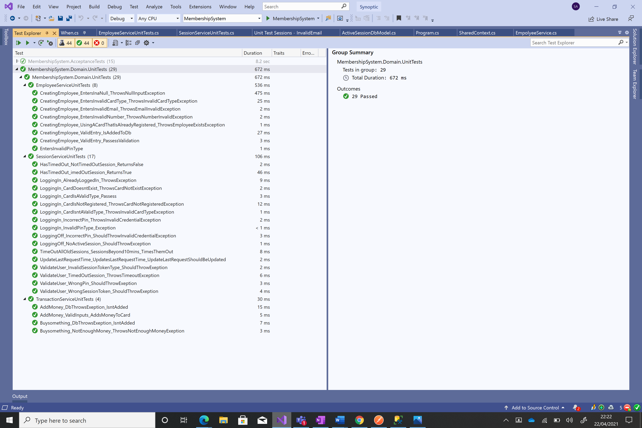

### Employee Service Unit Tests

|  |  |  |  |  |  |
| --- | --- | --- | --- | --- | --- |
| Test Number | Test description | Test Tools | Expected Outcome | Result of Test | Pass/Fail |
| 1 | This is a test for the method which handles creating employee’s. This test enters a null value for one of the properties into the method and expects an NullInputException to be thrown. | Nunit, Moq | Throws Null Input Exception | Threw Null Input Exception | Pass |
| 2 | This is a test for the method which handles creating employee’s. When an invalid email is entered a EmailInvalidException should be thrown. | Nunit, Moq | Throws Email Invalid Exception | Threw Email Invalid Exception | Pass |
| 3 | This is a test for the method which handles creating employee’s. When an invalid phone number is entered a NumberInvalidException should be thrown. | Nunit, Moq | Throws Number Invalid Exception | Threw Number Invalid Exception | Pass |
| 4 | This is a test for the method which handles creating employee’s. This test enters a card that is already registered into the method and expects an EmployeeExistsException to be thrown. | Nunit, Moq | Throws Employee Exists Exception | Threw Employee Exists Exception | Pass |
| 5 | This is a test for the method which handles creating employee’s. This test enters a valid entry and checks to see if an exception is thrown. | Nunit, Moq | Passes validation | Passed validation | Pass |
| 6 | This is a test for the method which handles creating employee’s. This test enters a valid entry and checks if the method adds it to the database. | Nunit, Moq | To be added to the database | Was added to the database | Pass |
| 7 | This is a test for the method which handles creating employee’s. This test enters an invalid card type in the registration input and the method should throw an InvalidCardTypeException. | Nunit, Moq | Throws a Invalid Card Type Exception | Threw a Invalid Card Type Exception | Pass |
| 8 | This is a test for the method which handles creating employee’s. This test enters an invalid pin type and should throw a invalid pin type exception. | Nunit, Moq | Throws Invalid pin type exception | Threw Invalid pin type exception | Pass |

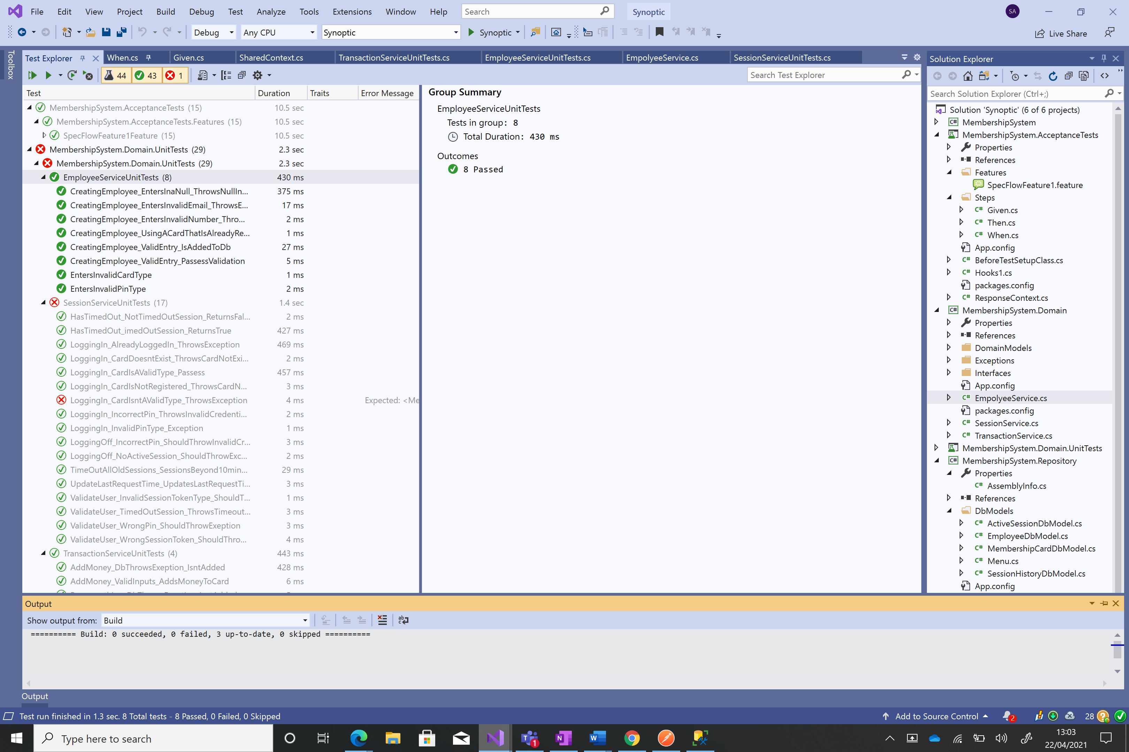

### Transaction Service Unit Tests

|  |  |  |  |  |  |
| --- | --- | --- | --- | --- | --- |
| Test Number | Test description | Test Tools | Expected Outcome | Result of Test | Pass/Fail |
| 1 | This is a test for the method which reduces the amount of money in a card by buying an item. When an amount above the balance of the card is attempted to be subtracted from the card, the method should throw a  NotEnoughMoneyException. | Nunit, Moq | Throws not enough money exception | Threw not enough money exception | Pass |
| 2 | This is a test for the method which adds money to a card. When the database throws an exception there should be no changes made to the database. | Nunit, Moq | No changes to the database | No change to the database | Pass |
| 3 | This is a test for the method which adds money to a card. When a valid set of inputs is entered the money on he card should increase. | Nunit, Moq | Card balance to be updated | Card balance was updated. | Pass |
| 4 | This is a test for the method which reduces the amount of money in a card by buying an item. When the database throws an exception there should be no changes made to the database. | Nunit, Moq | No changes to the database | No change to the database | Pass |

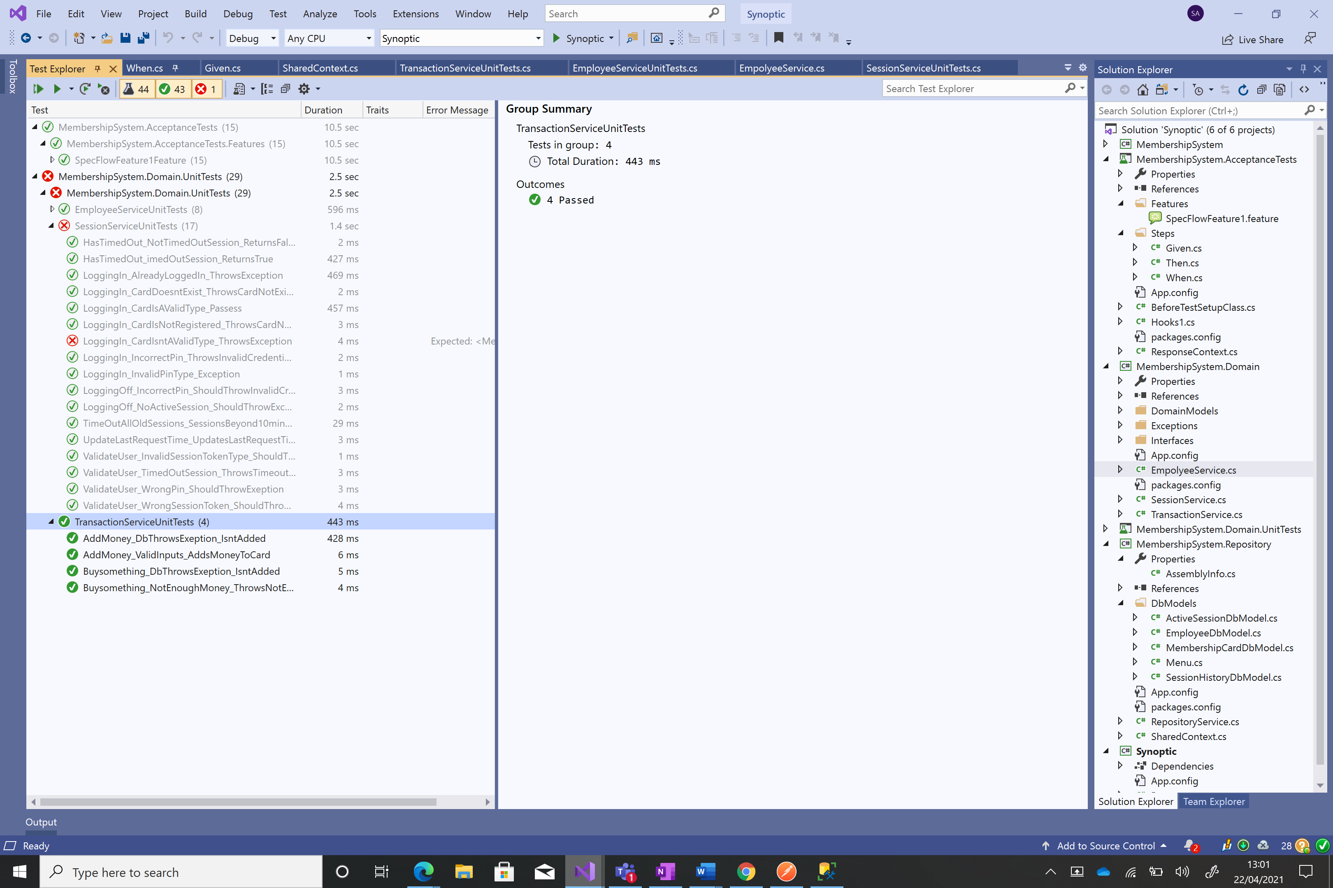

## Acceptance Tests

I used Specflow for my acceptance tests. This allowed me to easily transfer my gherkin requirements directly into code and was able to reuse code for different scenarios to refrain from repeating code. This code was separate from the system and did not reference the domain layer and only referenced the entity framework database context to setup the database ready for each scenario and on one occasion check if the change was successfully made.

|  |  |  |  |  |  |
| --- | --- | --- | --- | --- | --- |
| Test Number | Test description | Test Tools | Expected Outcome | Result of Test | Pass/Fail |
| 1 | This test calls the logging in function and attempts to login using the credentials of a registered user. | Specflow | Ok result | Ok result | Pass |
| 2 | This test calls the logging in function and attempts to login using the credentials of an unregistered user. | Specflow | Bad request result | Bad request result | Pass |
| 3 | This test calls the logging in function and attempts to login using the credentials of a card which is not registered. | Specflow | Result specifying the card does not exist | Result specifying the card does not exist | Pass |
| 4 | This test calls the logging in function and attempts to login using the credentials of a card which is registered but using an incorrect pin. | Specflow | Authentication error | Authentication error | Pass |
| 5 | This test calls the registration function and attempts to register a user using a unregistered valid card and valid parameters. | Specflow | Ok result | Ok result | Pass |
| 6 | This test calls the registration function and attempts to register a user using a unregistered valid card however an invalid email format. | Specflow | Result containing the message email is invalid | Result containing the message email is invalid | Pass |
| 7 | This test calls the registration function and attempts to register a user using a unregistered valid card however an invalid phone number format. | Specflow | Result containing the message Invalid Phone Number | Result containing the message Invalid Phone Number | Pass |
| 8 | This test calls the registration function and attempts to register a user using a unregistered valid card however doesn’t enter a property leaving it null. | Specflow | Result containing the message You have inputted a empty value | Result containing the message You have inputted a empty value | Pass |
| 9 | This test calls the add money function and attempts to add £5. | Specflow | The balance of the card to increase by £5 an a Ok result | Ok result and the balance of the card increased by £2 | Pass |
| 10 | This test calls the add money function and attempts to add £5 after over 10 minutes of inactivity. | Specflow | Timeout Result | Timeout Result | Pass |
| 11 | This test calls the add money function and attempts to buy something for £2 while having a balance of £10. | Specflow | Ok result The balance of the card to decrease by £2 | Ok result and he balance of the card decreased by £2 | Pass |
| 12 | This test calls the add money function and attempts to buy something for £5 while having a balance of £1. | Specflow | Bad request result | Bad request result | Pass |
| 13 | This test calls the add money function and attempts to buy something after over 10 minutes of inactivity. | Specflow | Timeout Result | Timeout Result | Pass |
| 14 | This test calls the logging in function and attempts to log out using the credentials of a logged in user. | Specflow | Ok result | Ok result | Pass |
| 15 | This test calls the logging in function and attempts to log out while currently not logged in. | Specflow | Bad request result | Bad request result | Pass |

